BATCH 29
2303A51684
ASSIGNMENT 4.2
Lab 4: Advanced Prompt Engineering – Zero-shot, One-shot, and Few-shot Techniques

Task Description-1
• Zero-shot: Prompt AI with only the instruction. Write a Python function to determine
whether a given number is prime

Prompt: Write a Python function to check if a number is prime.
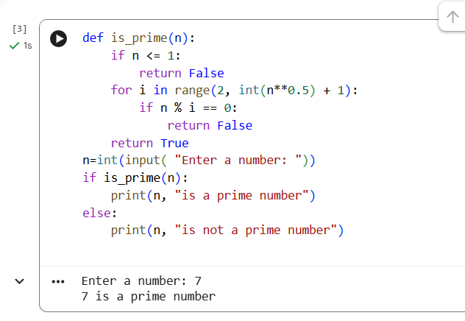

Task Description–2: One-shot Prompting
Prompt: Generate a function that calculates the sum of elements in a list.
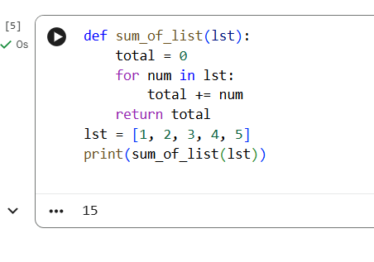
Task Description–3: Few-shot Prompting
Prompt: Create a function that extracts digits from an alphanumeric string.
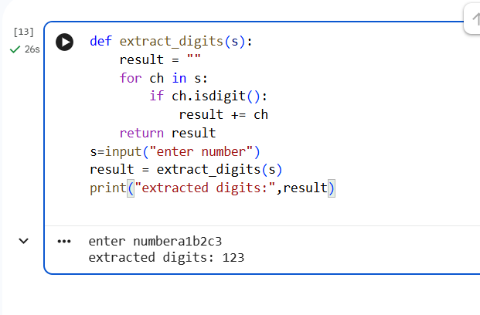
Task Description–4: Zero-shot vs Few-shot Comparison
Prompt: Generate a function to count vowels in a string.
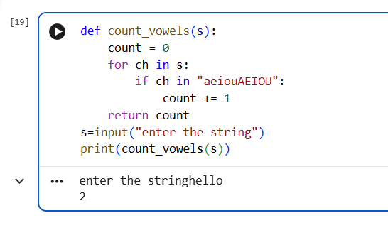

Task Description–5: Few-shot Prompting
Prompt: Find the minimum of three numbers without using min().
